Schedule 1
Part 1
LLC “Acad. Nikoloz Kipshidze Central University Clinic” (Republican Hospital)
Location: #29, Vazha-Pshavela ave. Tbilisi, 0160, Georgia. Cadaster code: 01.10.15.007.081
Land plot area – 77,035 sq.m
Buildings total area – 67,345 sq.m
Owners:
- LTD "Clinics Development Company" (Main owner)
- Georgian Apostolic Autocephalous Orthodox Church Building - building # 4 - 458.96 sq. m. (66 sq.m. at the basement level, 197.06 sq.m - on the 1st floor, 195.9 sq.m - on 2nd floor
- LTD "Assets’ Management and Development Company" – 12.42 sq.m of the building #2, on the technical floor (below the roof) and 10.0 sq.m. - On the roof.

Description of the buildings located on the territory
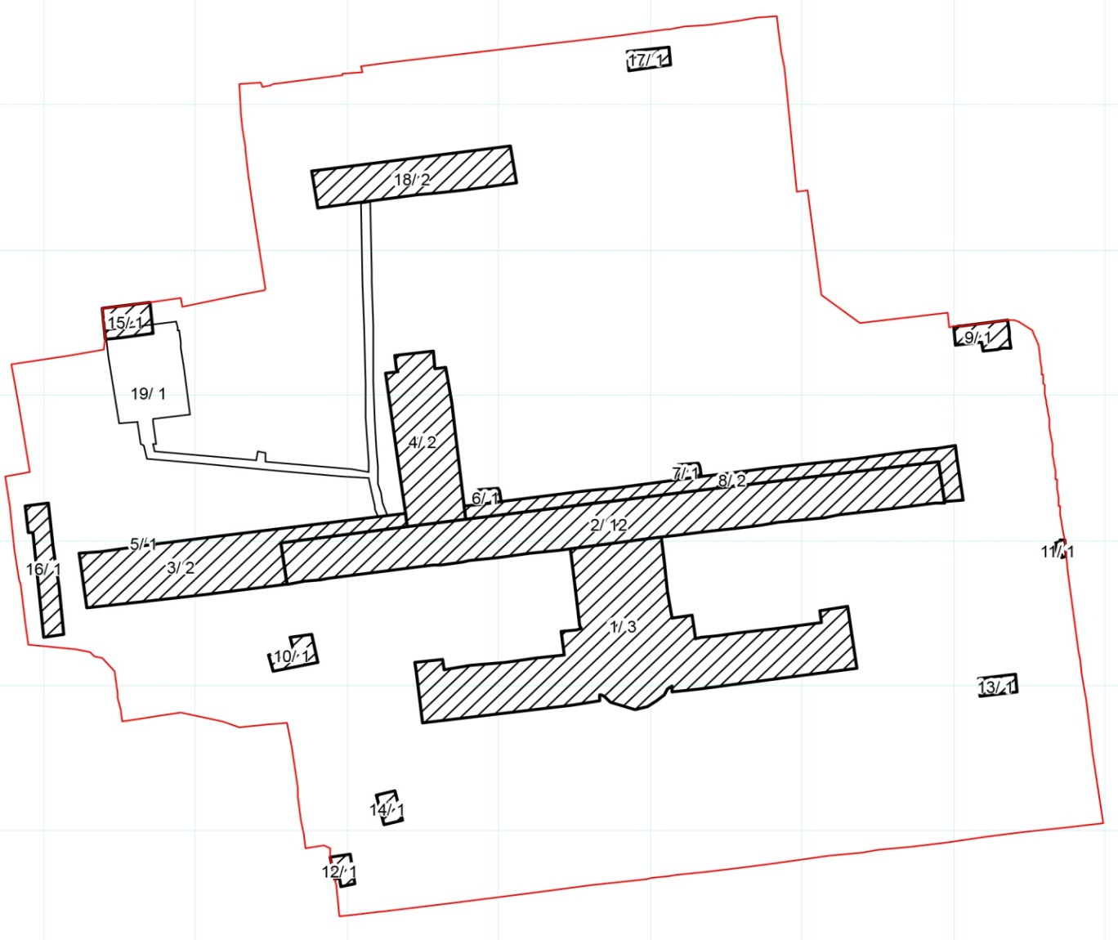

Building #1
Three-story building, added in 2006. Total area of ​​13,239.49 sq.m. (including: basement - 3,330.02 sq.m, 1st floor - 3,352.31 sq.m, 2nd floor - 3,395.96 sq. m, technical floor - 3,161.2 sq. m)
LLC "Academic Nikoloz Kipshidze Central University Clinic" is mainly functioning at this premises. Patients’ wards, operating blocks and medical departments are located on I and II floors. The clinic’s administration occupies III floor.
Building #2
This is a twelve-story building, as well as level zero (ground level), technical floor (sub-roof) and basement. The hospital was initially functioning in this building. The building consists of 4 independent sections, has 15 lift shafts, five staircases, among them 2 - emergency evacuation staircases.
Fourth, Western Section:
At all 12 floors partitions, floor screeds (concrete layer) and internal vertical and horizontal communications have been dismantled/removed;
• The third floor is renovated and leased by JSC "Partnership Fund" (total area - 975 sq. m of lease validity - December 31, 2022), which currently operates here its several subsidiaries (among them – Clinics Development Company as well).
- First floor
  - Partial lease is issued to "Georgian Center for Coloproctology – Gela Mukhashavria Clinic" (373.75 sq.m. lease agreement - until 31st December 2020).
  - The unit of LLC "Nikoloz Kipshidze Central University Clinic" (Sports Medicine and Rehabilitation Department) also operates here
  - Section (15 sq.m.) - lives 1 inhabitant
- Nil floor (ground level) - there are 2 inhabitants on the ground floor
- Lower part of the “en-pente-douse” (sloping) is leased to the individual entrepreneur, for purpose of auto tech service. (total area of ​​the lease – 23.64 sq.m. term of lease - January 01, 2020).
- 12.11 sq.m on the technical floor and 10 sq.m of the roof are owned by the "Assets Management and Development Company". This is a state company, which in turn has leased this space to various mobile communication operator companies: Beeline, Magticom.
Third, second, first sections
In these sections the internal dismantling was not conducted.
There are construction and household garbage and old amortized inventory of the clinic at floors of these sections.
• First floor
- The unit of LLC. "Kipshidze Central University Clinic" (Nephrology and hemodialysis department) is operating here.
- In part (15 sq.m section) there are 2 inhabitants living
- Nil floor (ground level) - is used as a warehouse.
Building # 3
Two-story, mostly dormant, inside - half-destroyed building;
Part of the first floor is leased to the Laundry Ltd. (the term of validity of 70 sq.m lease - until October 23, 2022)
At the second floor "Tbilisi State Medical University" Department is functioning.
Building # 4
The two-story building. There is building and household garbage and old amortized inventory of the clinic at the second floor.
458.96 sq.m is owned by the Georgian Church (including 66 sq.m. at the basement, 197.06 sq.m - at first floor, and 195.9 sq.m – at second floor.
On the first floor 341.02 sq. m area was leased to the "Biomedical Systems and Gases" LLC, term of lease - January 01, 2020
Buildings # 5,6,7,8
Auxiliary buildings to the main building (#2) (photo)
Building # 9
Undefined function. Very obsolete building, repair is very much needed. Total area - 121 sq.m.
Building # 10
Clinic’s warehouse, total area -109 sq.m.
Building # 11
Leased to individual Entrepreneur. Total area - 13,92 sq.m, term of lease - January 01, 2020.
Building # 12
Leased to individual Entrepreneur. Total area - 564 sq.m land plot and 60 sq.m building attached to it. Term of lease - 01 January 2020.
Building # 13
Current Transformer Substation, 2 Transformer # 919, Total Area - 75 sq.m.
Building # 14
Current transformer substation, 2 transformer # 918, total area - 66 sq.m.
Building # 15
Underground shelter, auxiliary unfinished construction, total area - 172 sq.m.
Building # 16
Clinic’s boiler, diesel generator, total area - 310 sq.m.
Building # 17
Inactive Transformer Substation, 1 Transformer in “Not Working” Condition, #725, Total Area - 89 sq.m
Building # 18
The building is in a state of emergency. In the part of the building the clinic's pathoanatomy department is functioning, the remaining part is not functional. Total area - ​​2000 sq.m.
Building # 19
Underground shelter. Nonfunctional, full of household garbage.

Yard - Part of the yard is leased to the driving school. (Total area of lease - 881 sq. m., term of lease 01 January 2020).

Remark:
- Leased Property does not include 8 stores, and ground floor in building #2 western, fourth section, 975 sq.m each and building #9, 121 sq.m, totally 8896 sq.m. For avoidance of any doubt the Tenant is obliged to negotiate with inhabitants of the said property in order to move them out of the mentioned property as well as from the Leased Property.
- Tenant has an option to require transfer of ground floor and 6, 7, 8 floors within 2 years from signing date of the Agreement, if the detailed design and general layout of the whole hospital and infrustructure include the said space. In this case the said space shall be used only for the first and second group services as set out in Schedule #3. For avoidance of any doubt this option may be exercised and shall be effective as long as the other Leased Property entirely is planned and subsequently used only for the first and second group services as set out in Schedule #3.
- In case any space (other than spaces that are not included in the Leased Property) is leased before announcement of auction, the Bidders will be notified during auction. The said lease period shall not exceed one year.

Part 2
List of movable property

